TASK 21:

* Create a Virtual Machine
* Install SQL server on the Virtual Machine
* Access the SQL Server using SSMS (SQL Server Management System).

Steps to perform above task:

Step 1: Create virtual machine with Windows server Image by logging inside Azure Portal.

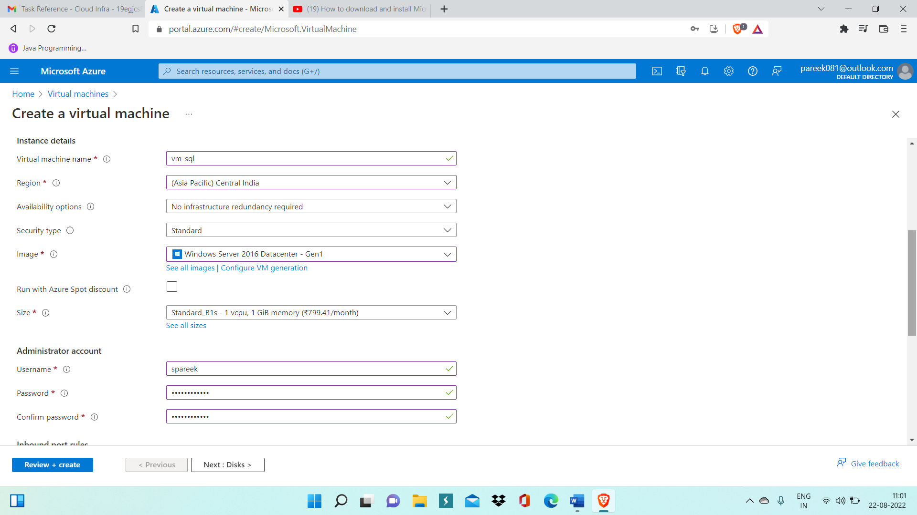

Step 2: Now Enter Authentication details and Connect to VM.

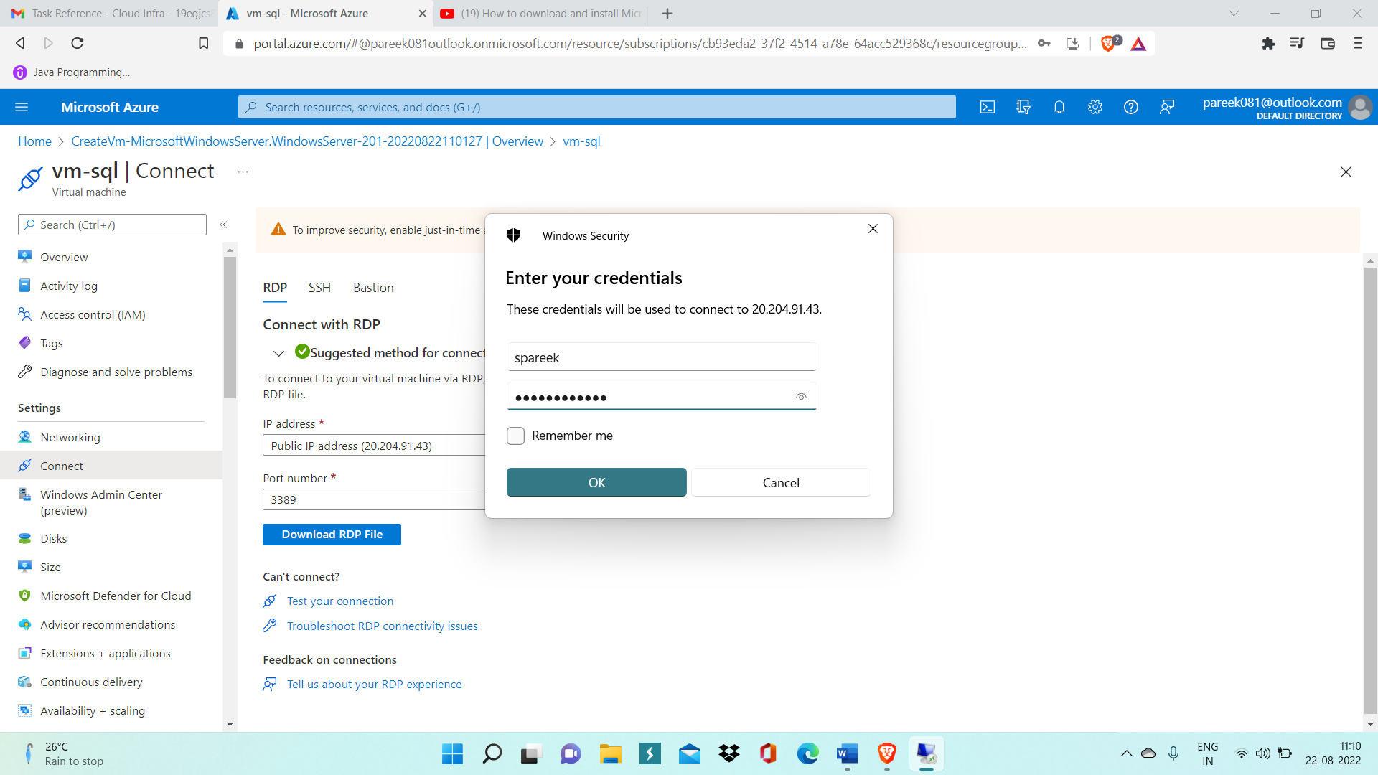

Step 3: Now after connecting to VM, now inside VM download Microsoft SQL Server 2019.

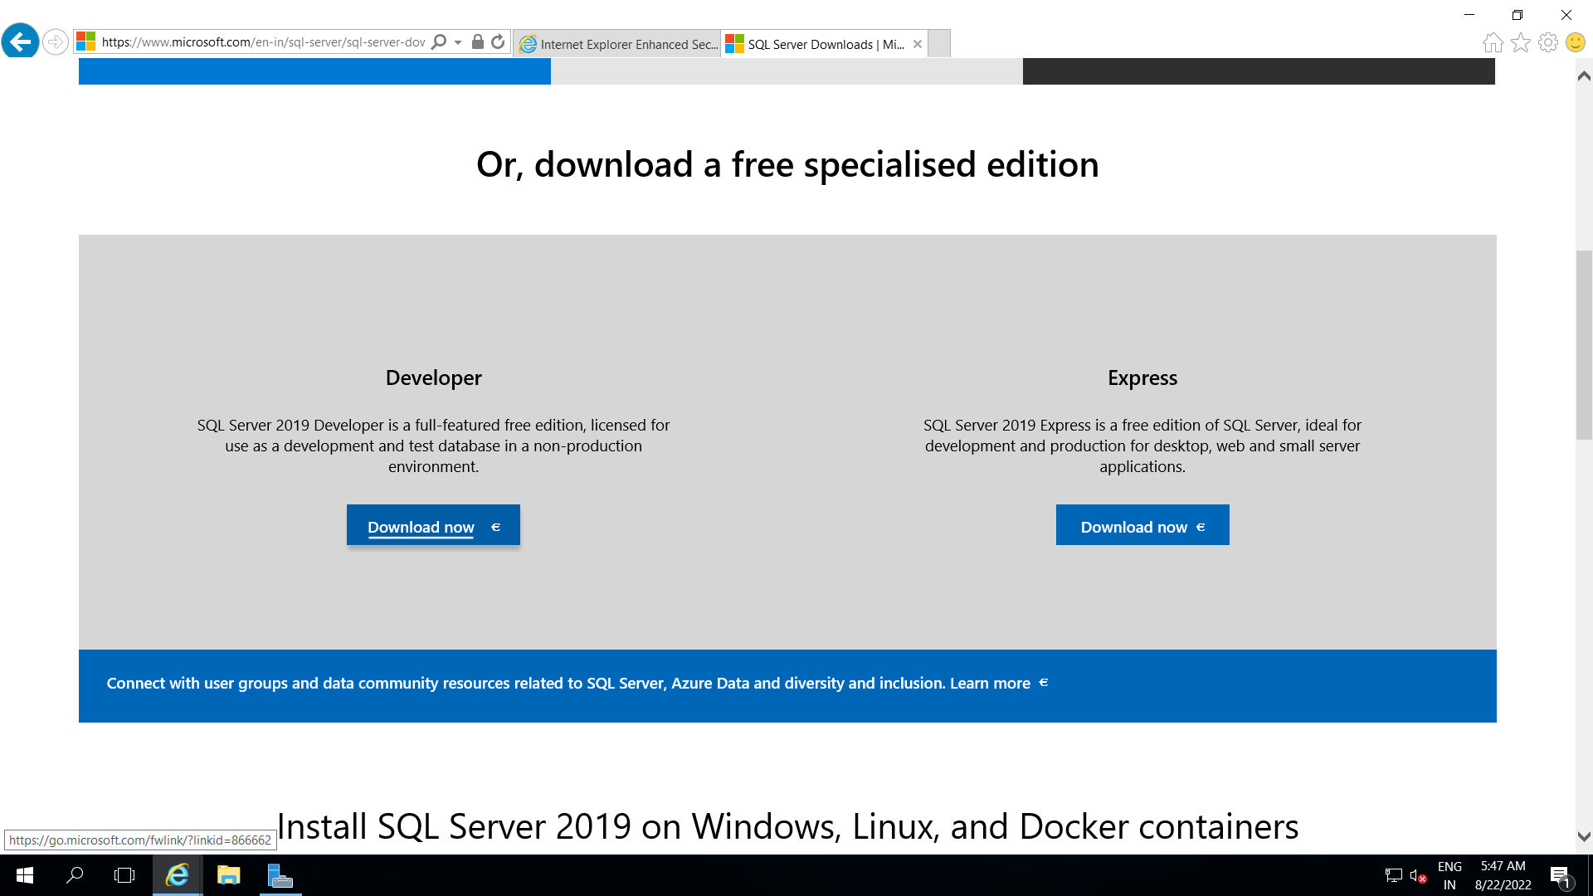

Step 4: Now enter All details and download it inside VM.

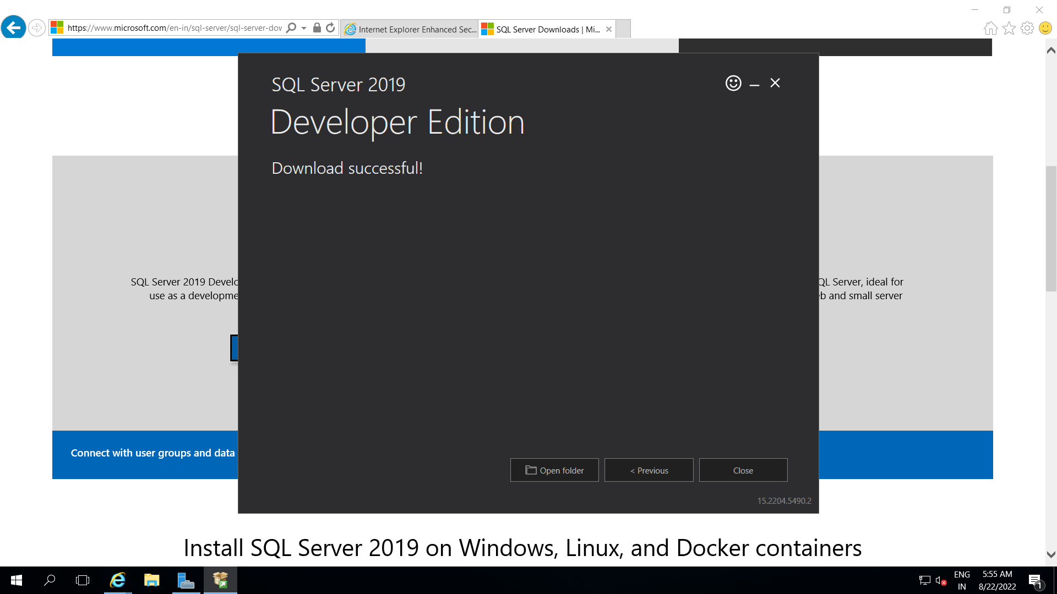

Step 5: Now, Run SQL Server Setup present inside C drive

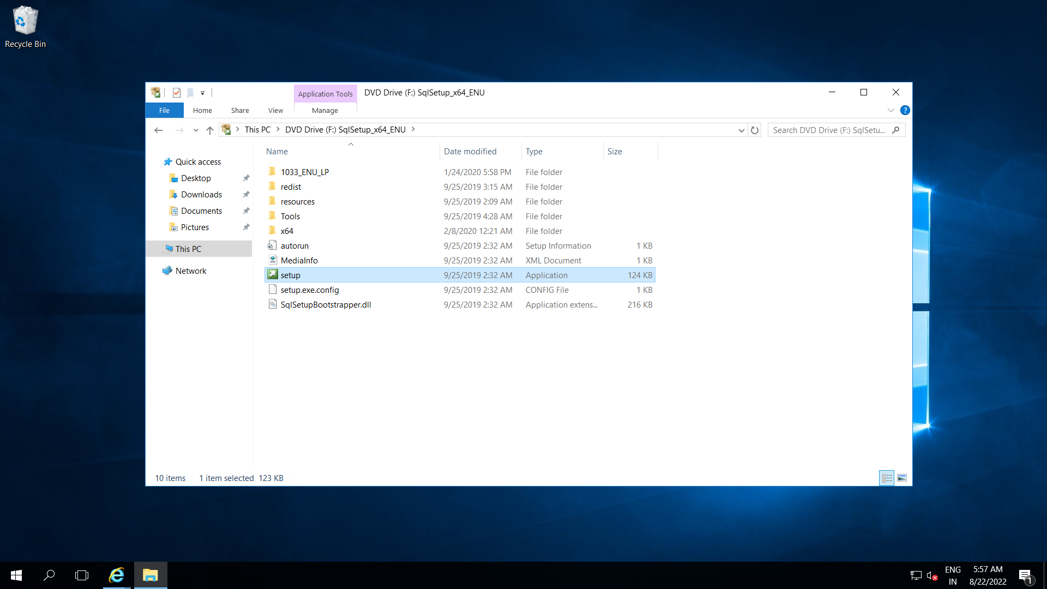

Step 6: Now, open SQL Server Installation configuration windows and install sql server stand-alone.

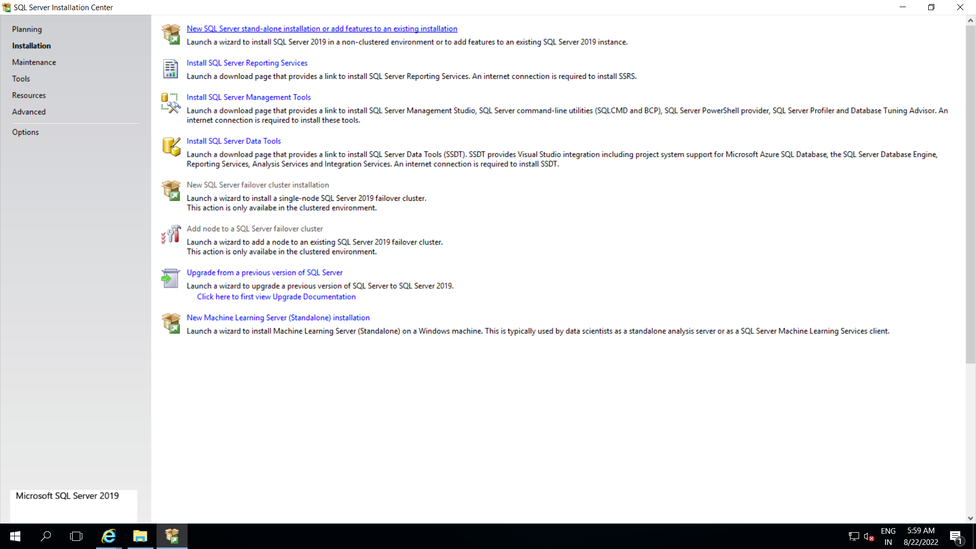

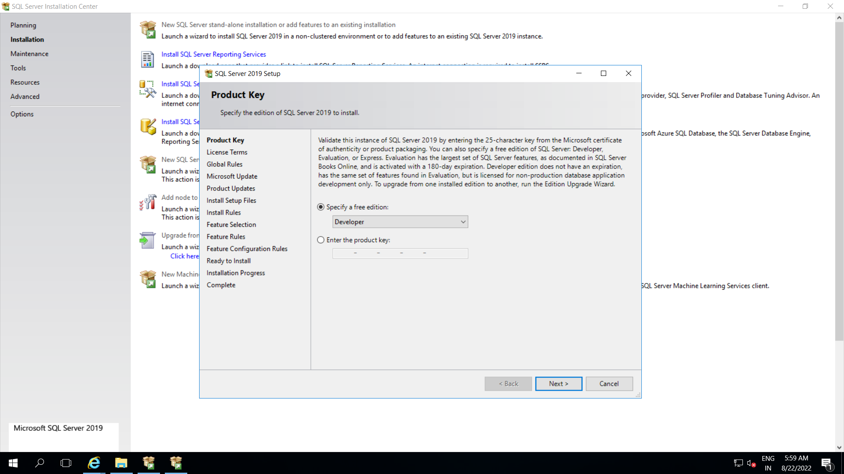

Step 7: Now select all features to be installed inside SQL server

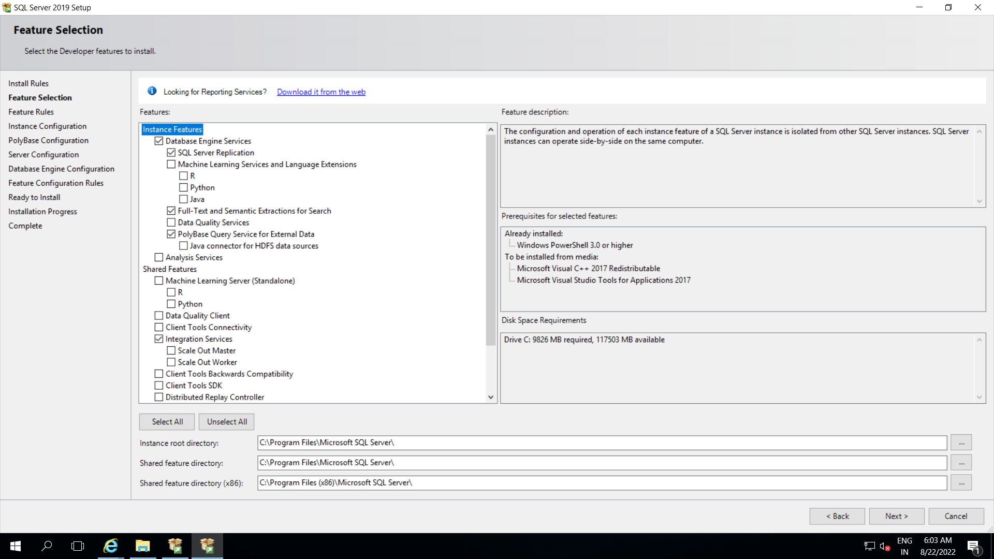

Step 8: Now after entering all the details complete installation of SQL server.

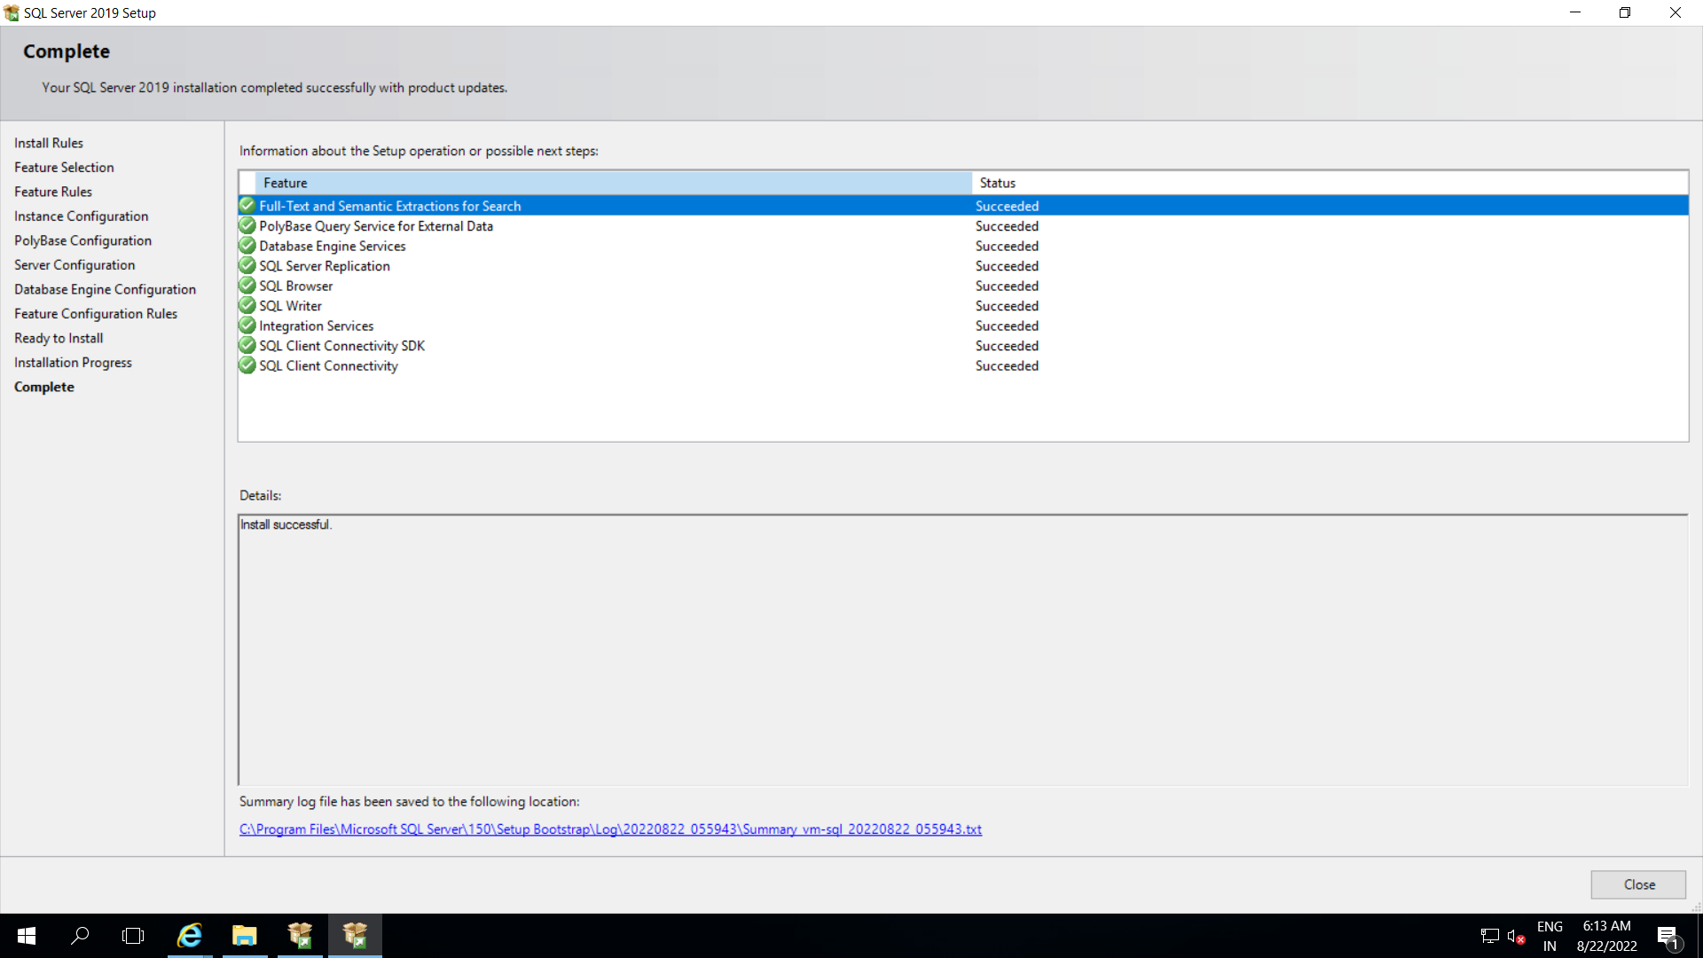

Step 9: Now inside VM download SQL Server Management Studio

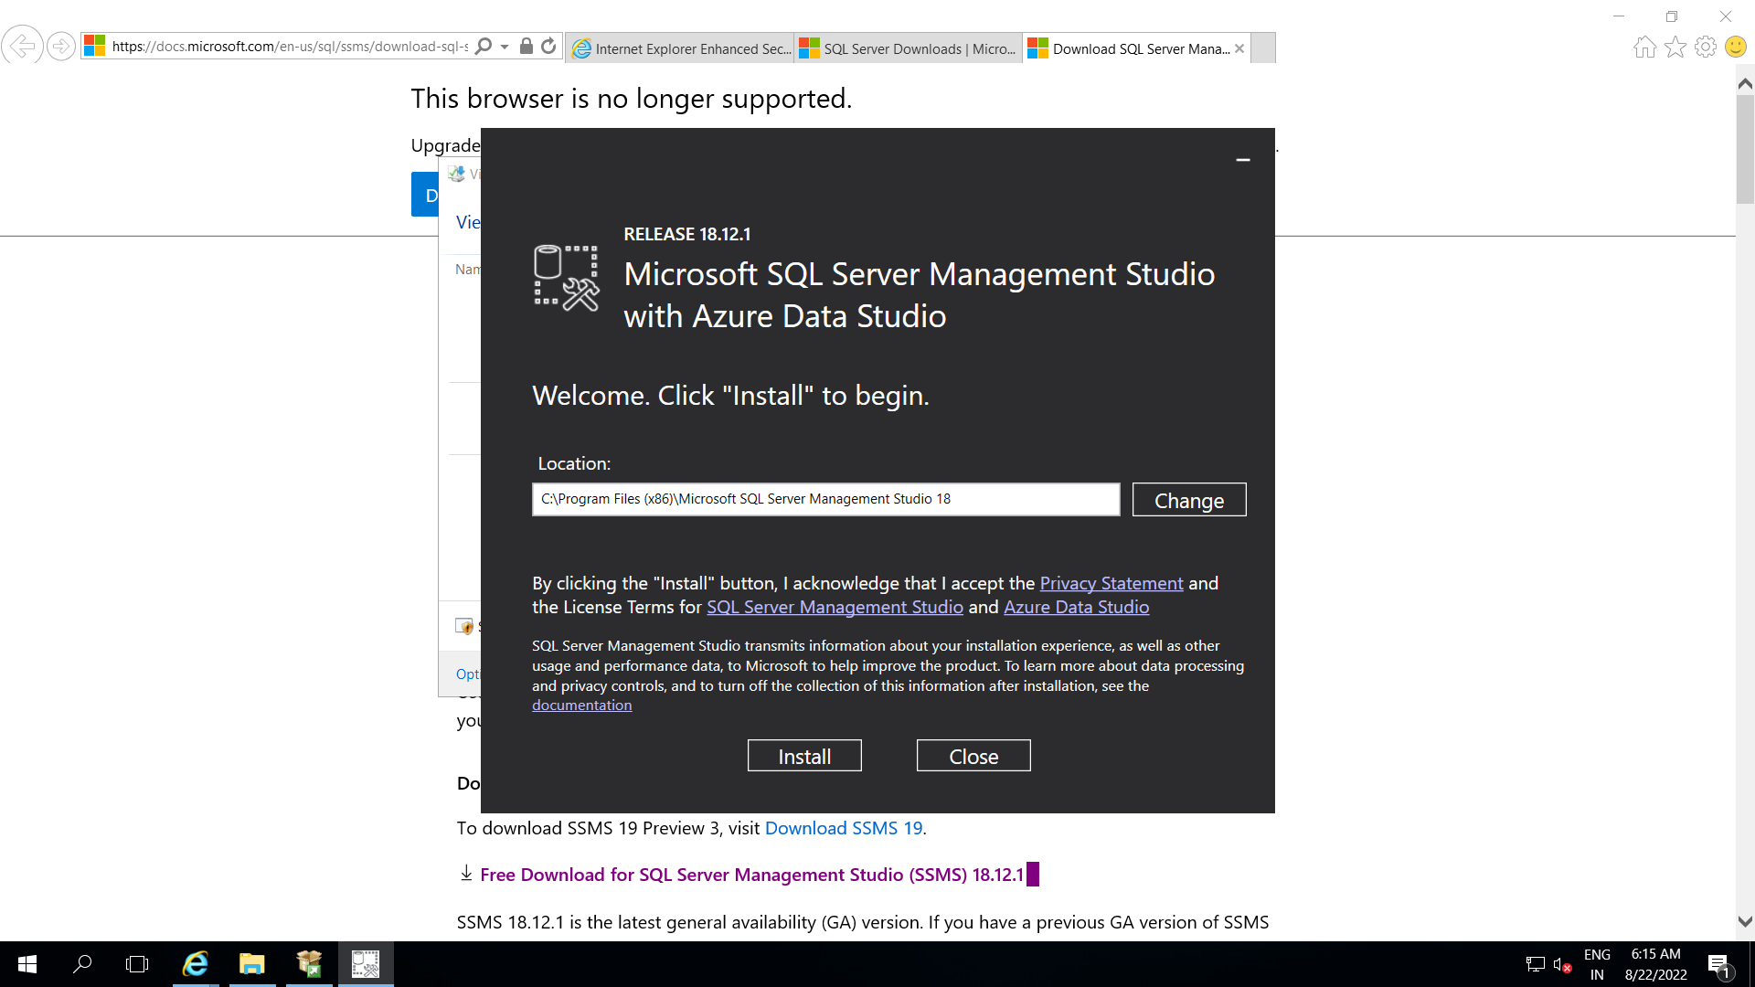

Step 10: Now open SQL server Configuration Manager

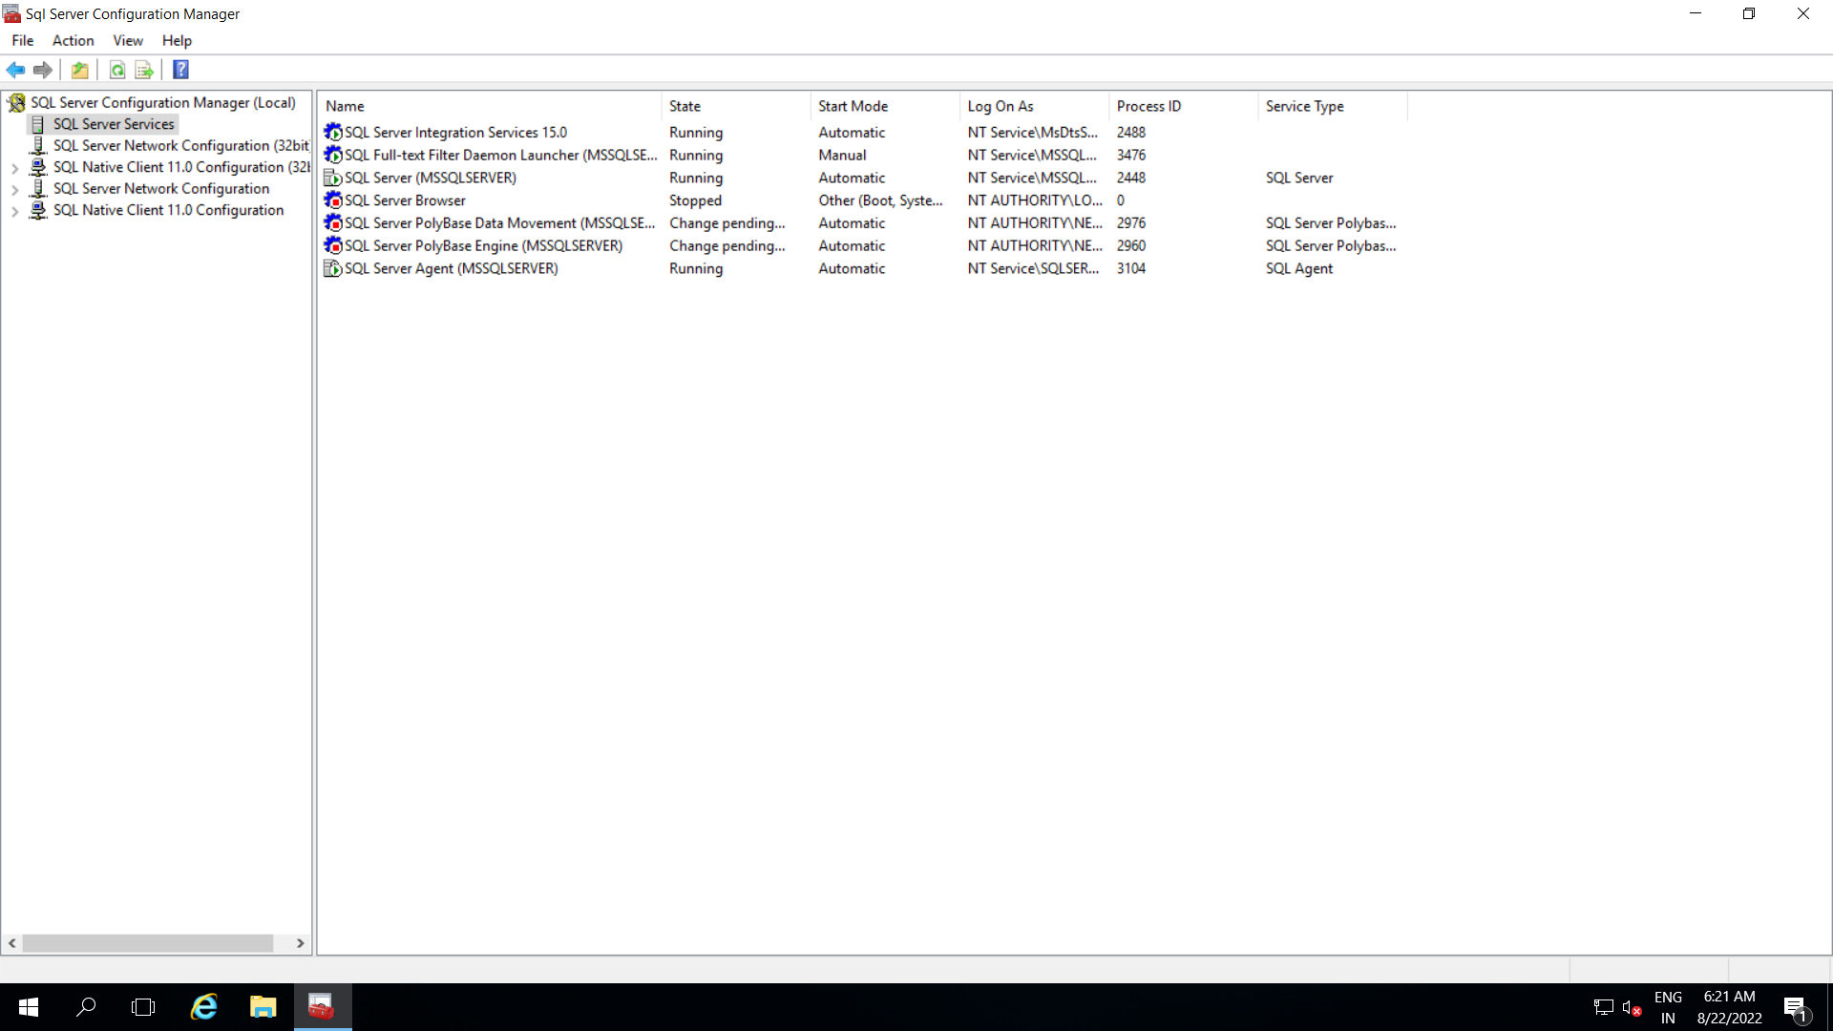

Step 11: Now enable SQL Server Network Configuration, enable all protocols.

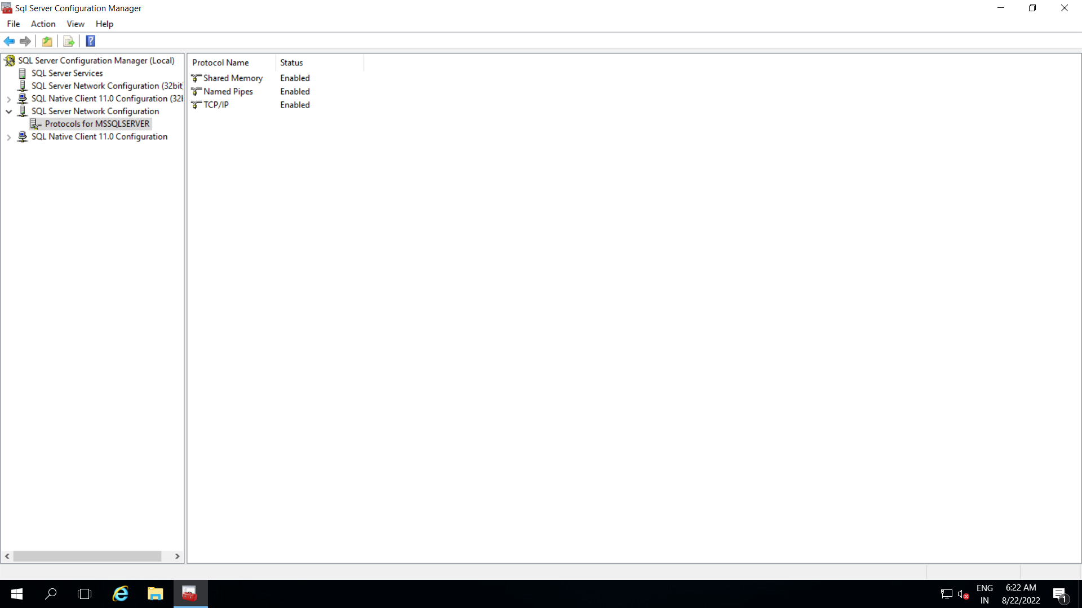

Step 12: Open SQL Server Management Studio

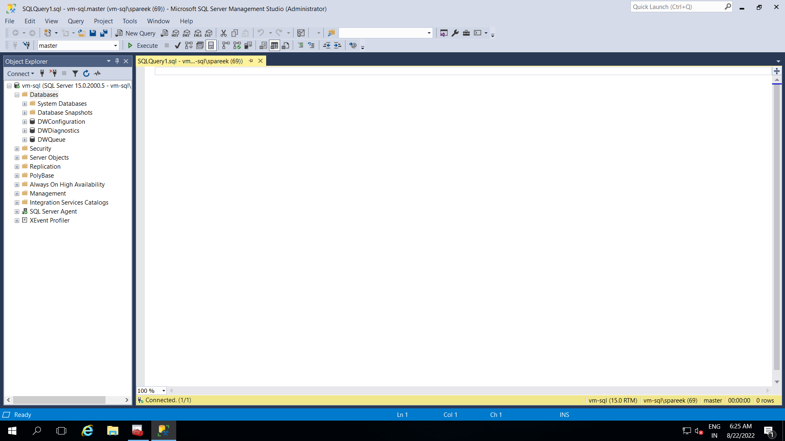

Step 13: You can perform a demo query to check SQL server is working properly or not

Query: select * from sys.master_files

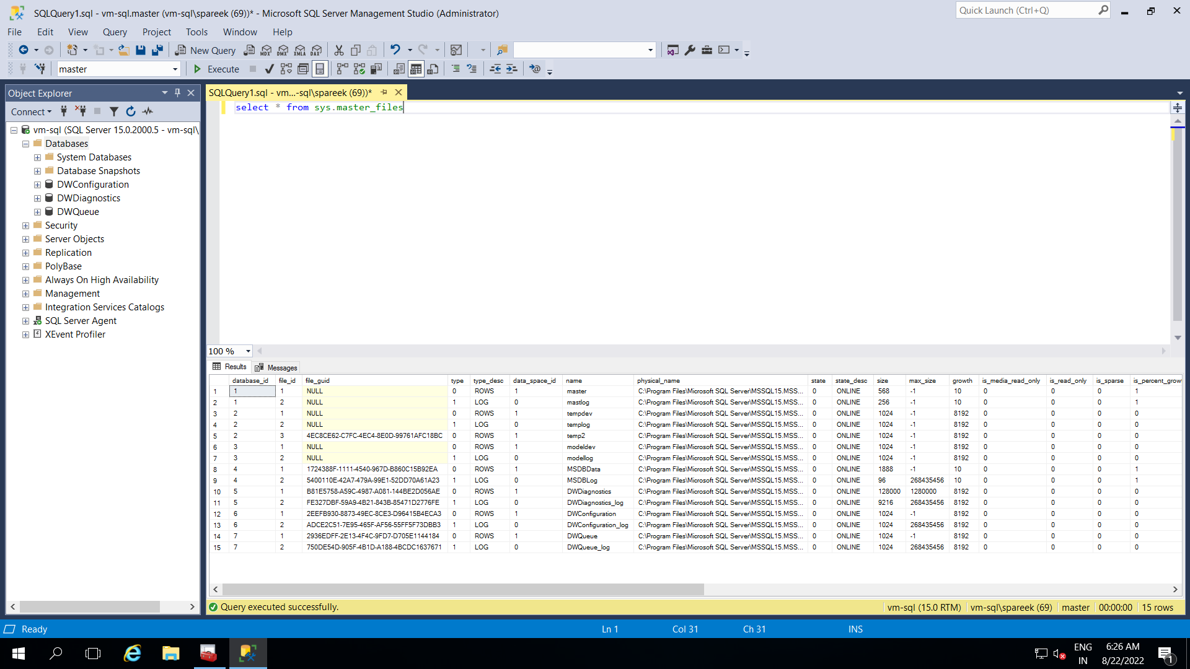

Query is successfully executed and we can now confirm that SQL server is correctly installed.